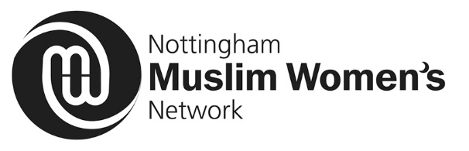
Volunteer joining form
Name:
Address:
Post code:
Email address:
Home Tel:
Mobile:

Twitter:
Facebook:

I am interested in volunteering with Nottingham Muslim Women’s Network NMWN) because:

Your hobbies, skills and interests include:

What would you like to gain from volunteering with NMWN?

What issues do you think effect Muslim Women?

PROJECT (If identified)

DATE OF BIRTH

GENDER

CARER/PARENT

Are you an unpaid carer? Yes  No 

Are you a parent? Yes  No

ETHNIC ORIGIN:

Choose one section from (a) to (e) then tick the appropriate box to indicate your ethnic origin
(a) White
 British
 Irish
 Any other White background
 European
Please specify ……………..…

(b) Mixed Parentage
 White & Black Caribbean
 White & Black African
 White & Asian
 Any other mixed background
Please specify ………………………

(c) Asian
 British 
 Indian
Pakistani
 Bangladeshi
 Any other Asian background
Please specify…………………..

(d) Black
 British 
 Caribbean
 African
 Any other Black background
Please specify……………………………..…

(e) Chinese or Other Far Eastern
 British  Chinese  Korean
 Japanese  Vietnamese   Any additional Chinese or Far Eastern background
Please specify ………………………………..

DISABILITY
Do you have any disabilities? Yes  No 

SEXUAL ORIENTATION

Emergency Contact
Name: ________ _______________________________________________

Relationship to you: _____________________________________________

Telephone: ______________________________________________________

Mobile: ________________________________________________________
Signature:
Date:

Please complete and return to:
Nottingham Muslim Women’s Network
Unit 12, John Folman Business Centre
33 Hungerhill Road
St Anns
Nottingham
NG3 4NB
or
Email- enquiries@nmwn.co.uk

Volunteer Application Process
- Complete the Volunteer Joining Form. We will support you to complete this. Hand or send or email in your completed form to Nottingham Muslim Women’s (NMWN)worker

- After completing the form you will be given you an opportunity to have an informal interview. You will be able to find out more about NMWN and to discuss and agree what volunteering work you would like to do.

- NMWN may need to a DBS (formerly known as a CRB) check on some volunteers – particularly volunteers who wish to volunteer with children or vulnerable adults.

Comments ( NMWN office)

